DCC-GARCH correlation: USDCAD and EURGBP
Method 09 / GARCH(1,1) + Engle DCC / Alpari D1 full available history

Study setup
Logical pair: USDCAD , EURGBP
Broker symbols: USDCAD_i , EURGBP_i
Snapshot: 2026-11-03_majors_alpari_D1
Timeframe: D1
Matched return window: 1999-01-06 to 2026-11-02 (UTC bar dates)
Matched return count n: 7185
Dropped unfinished last bar dated 2026-11-03 UTC after a tick-volume check against the prior complete day.
USDCAD GARCH(1,1): mu=-0.000001, omega=0.001256, alpha=0.043641, beta=0.951263
EURGBP GARCH(1,1): mu=-0.000026, omega=0.000657, alpha=0.046408, beta=0.951884
DCC: a=0.008672, b=0.989217, a+b=0.997889
Burn-in ignored in path summaries and chart: first 60 updates
Complete matched rows (Excel): USDCAD-EURGBP_DCC_D1.xlsx
Complete matched rows (HTML table): USDCAD-EURGBP_DCC_D1_data.html

Method carried forward
DCC-GARCH first fits a constant-mean GARCH(1,1) on each matched daily log return of close, ln(close_t / close_t-1), then updates Engle (2002) dynamic conditional correlation on the standardised shocks z = residual / conditional sigma. Quotes are not inverted. Correlation targeting sets Q_bar to the sample correlation of z; a and b are estimated by maximising the bivariate Gaussian DCC likelihood with a >= 0, b >= 0, and a + b < 1. Path summaries ignore the first 60 updates. The headline is rho on the last day. Same-sample Pearson r on log returns is a side check only. A high |rho| does not prove cause, lead-lag, or a trading signal.

Results
Latest DCC rho: 0.016929
Post-burn-in path (n=7125): mean=-0.022145, median=-0.032348, min=-0.349655, max=0.296535, std=0.136160
Share of post-burn-in days with |rho| >= 0.4: 0.00%; |rho| >= 0.7: 0.00%
Same-sample Pearson r: -0.014622
Latest rho minus r: 0.031551

Conclusion
Over 7185 matched daily log-return rows for USDCAD and EURGBP (broker quote directions unchanged), latest DCC rho is 0.0169 (positive, weak conditional linear link in this sample) with fitted a=0.0087, b=0.9892 (a+b=0.9979). After a 60-day burn-in, path mean is -0.0221 and std is 0.1362. Same-sample Pearson r is -0.0146 (latest rho minus r = 0.0316). This does not establish cause, lead-lag, or a lasting trading rule.

Charts
Daily closes

Daily log returns
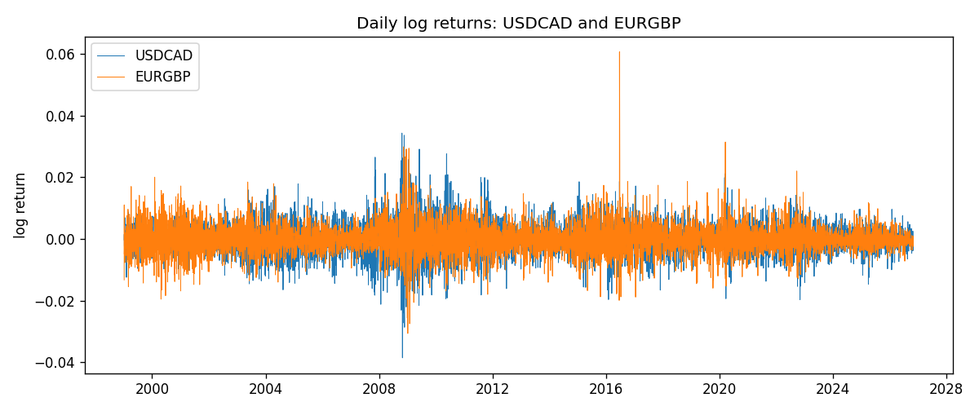
DCC rho path with Pearson r reference
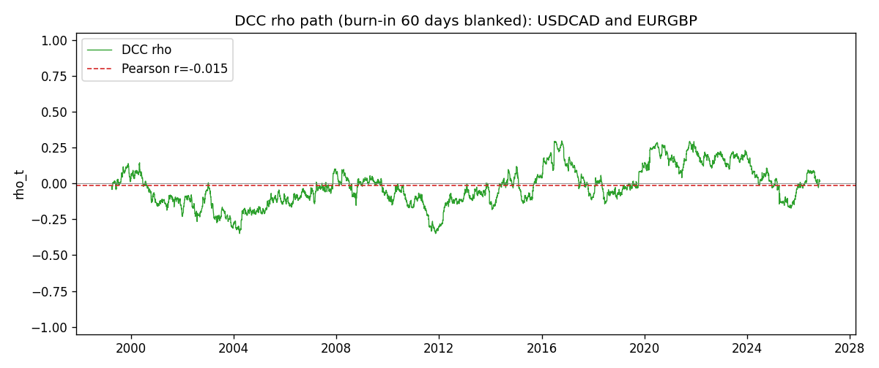

Data report
Every matched row that entered the DCC recursion is stored in the sibling Excel workbook named USDCAD-EURGBP_DCC_D1.xlsx. Embedding all rows as a Word table is impractical at this length; the Word file holds the column list, column summaries, and the first and last 15 matched rows.
Columns: time, USDCAD_open, EURGBP_open, USDCAD_high, EURGBP_high, USDCAD_low, EURGBP_low, USDCAD_close, EURGBP_close, USDCAD_tick_volume, EURGBP_tick_volume, USDCAD_spread, EURGBP_spread, USDCAD_real_volume, EURGBP_real_volume, USDCAD_log_return, EURGBP_log_return, USDCAD_sigma, EURGBP_sigma, USDCAD_z, EURGBP_z, q11, q22, q12, rho_t
Column summaries (matched calculation rows)
column | count | mean | std | min | 25% | 50% | 75% | max
USDCAD_open | 7185 | 1.2666594 | 0.16886861 | 0.9168 | 1.1183 | 1.29841 | 1.37203 | 1.6183
EURGBP_open | 7185 | 0.78693389 | 0.09666561 | 0.5734 | 0.6876 | 0.83387 | 0.86521 | 0.9769
USDCAD_high | 7185 | 1.2715589 | 0.16882635 | 0.9336 | 1.1227 | 1.30381 | 1.3764 | 1.619
EURGBP_high | 7185 | 0.79000929 | 0.09704455 | 0.5789 | 0.6896 | 0.8369 | 0.8681 | 0.9799
USDCAD_low | 7185 | 1.2621046 | 0.16891061 | 0.9056 | 1.11396 | 1.29347 | 1.36776 | 1.6102
EURGBP_low | 7185 | 0.78423344 | 0.09648411 | 0.5682 | 0.6855 | 0.83166 | 0.86287 | 0.9661
USDCAD_close | 7185 | 1.2666836 | 0.16885076 | 0.916 | 1.118 | 1.29833 | 1.3723 | 1.6137
EURGBP_close | 7185 | 0.78697576 | 0.09666885 | 0.5735 | 0.6878 | 0.83391 | 0.86533 | 0.977
USDCAD_tick_volume | 7185 | 81049.359 | 147325.09 | 37 | 5563 | 40946 | 71633 | 1410818
EURGBP_tick_volume | 7185 | 87109.869 | 145486.28 | 154 | 6553 | 44326 | 81375 | 1424684
USDCAD_spread | 7185 | 23.430202 | 18.259258 | 0 | 9 | 17 | 40 | 60
EURGBP_spread | 7185 | 21.335421 | 19.123862 | 0 | 4 | 13 | 40 | 50
USDCAD_real_volume | 7185 | 1.8384377e+10 | 9.670755e+10 | 0 | 0 | 0 | 0 | 2.5751613e+12
EURGBP_real_volume | 7185 | 2.7864528e+10 | 1.3519652e+11 | 0 | 0 | 0 | 0 | 3.5726265e+12
USDCAD_log_return | 7185 | -8.08e-06 | 0.00514591 | -0.03859748 | -0.00283484 | 5.597e-05 | 0.00272835 | 0.03436319
EURGBP_log_return | 7185 | 1.874e-05 | 0.00486681 | -0.03067367 | -0.00262366 | -0.00010035 | 0.00255918 | 0.06075387
USDCAD_sigma | 7185 | 0.00479602 | 0.00181736 | 0.00251056 | 0.00365045 | 0.00435032 | 0.00535867 | 0.01852984
EURGBP_sigma | 7185 | 0.0046283 | 0.00169323 | 0.00185771 | 0.0034331 | 0.00440574 | 0.00551675 | 0.01546402
USDCAD_z | 7185 | 0.00155166 | 1.0001171 | -4.070538 | -0.62801875 | 0.01104937 | 0.61223531 | 6.4145566
EURGBP_z | 7185 | 0.0081884 | 1.0000657 | -3.7918388 | -0.62167863 | -0.01834419 | 0.59954915 | 8.4871852
q11 | 7185 | 1.0022207 | 0.09795151 | 0.78848679 | 0.93680621 | 0.99488581 | 1.0548313 | 1.4696699
q22 | 7185 | 1.0029288 | 0.09992417 | 0.76586122 | 0.93996537 | 0.9973599 | 1.0555176 | 1.7491326
q12 | 7185 | -0.02116625 | 0.13998155 | -0.40236585 | -0.11433454 | -0.03104725 | 0.06838632 | 0.40857975
rho_t | 7185 | -0.02189986 | 0.1356203 | -0.34965517 | -0.11617366 | -0.03118665 | 0.07188718 | 0.29653514
First 15 matched rows (selected columns)
time | USDCAD_log_return | EURGBP_log_return | USDCAD_sigma | EURGBP_sigma | USDCAD_z | EURGBP_z | q11 | q22 | q12 | rho_t
1999-01-06 | -0.0003306769 | -0.013303338 | 0.0038629119 | 0.0056043673 | -0.085350369 | -2.3691739 | 1 | 1 | -0.020722571 | -0.020722571
1999-01-07 | 0.0015202092 | 0.011051402 | 0.0037848558 | 0.0061761569 | 0.40191362 | 1.7935132 | 0.99139074 | 1.0400058 | -0.018789203 | -0.018504104
1999-01-08 | -0.0020495197 | -0.004943862 | 0.0037220309 | 0.0064860962 | -0.55038335 | -0.75827505 | 0.98421204 | 1.0587985 | -0.01237892 | -0.012126396
1999-01-11 | -0.0035137769 | -0.0012752393 | 0.0036724697 | 0.0064213278 | -0.95652279 | -0.19460495 | 0.97833692 | 1.0544785 | -0.0086698043 | -0.0085358387
1999-01-12 | 0.0066194721 | 0.0033970309 | 0.0036733897 | 0.006275953 | 1.8022722 | 0.54535909 | 0.9778328 | 1.0455471 | -0.0070057341 | -0.0069286648
1999-01-13 | 0.0045420214 | 0.00042381861 | 0.0038567458 | 0.0061726585 | 1.1779354 | 0.072810727 | 0.99756908 | 1.0389628 | 0.0015500817 | 0.0015225904
1999-01-14 | 0.0069376546 | -0.0019793588 | 0.0038956131 | 0.0060285522 | 1.7811396 | -0.3240814 | 1.0009561 | 1.0299162 | 0.0022334291 | 0.0021997013
1999-01-15 | -0.0056905671 | -0.0076715819 | 0.0040820092 | 0.0059023334 | -1.3938212 | -1.2954139 | 1.0197863 | 1.0218321 | -0.002840422 | -0.0027825214
1999-01-18 | 0.00098344542 | 0.00071280921 | 0.0041700089 | 0.005994997 | 0.23607177 | 0.12317376 | 1.0277488 | 1.0274774 | 0.012805204 | 0.012461114
1999-01-19 | 0.002748513 | -0.0014261269 | 0.0040877057 | 0.0058567621 | 0.67262399 | -0.23912697 | 1.0192605 | 1.0186402 | 0.012875558 | 0.0126361
1999-01-20 | -0.0059646885 | 0.0019960086 | 0.0040435682 | 0.0057278168 | -1.4748639 | 0.35294875 | 1.0143039 | 1.0102627 | 0.01129808 | 0.011161009
1999-01-21 | -0.0042823796 | -0.00071240297 | 0.0041510539 | 0.0056111161 | -1.0314016 | -0.12239736 | 1.0243417 | 1.0025599 | 0.0066180616 | 0.0065306016
1999-01-22 | 0.0025057712 | -0.0017118406 | 0.0041613651 | 0.0054824498 | 0.60238578 | -0.30756752 | 1.0246325 | 0.99398983 | 0.0075977725 | 0.0075285486
1999-01-25 | 0.00085579808 | -0.0054402425 | 0.0041076477 | 0.0053673672 | 0.20858021 | -1.0088047 | 1.0188414 | 0.98620259 | 0.0058653238 | 0.005851344
1999-01-26 | 0.0001973879 | -0.00057438255 | 0.0040259204 | 0.0053711008 | 0.049271675 | -0.10217001 | 1.0103431 | 0.98650476 | 0.0039335105 | 0.0039400006
Last 15 matched rows (selected columns)
time | USDCAD_log_return | EURGBP_log_return | USDCAD_sigma | EURGBP_sigma | USDCAD_z | EURGBP_z | q11 | q22 | q12 | rho_t
2026-10-13 | -0.0046395653 | 0.00020130374 | 0.0028863578 | 0.0020136214 | -1.6070736 | 0.11269292 | 0.84479401 | 0.78777425 | -0.023211954 | -0.028453481
2026-10-14 | 0.0015184751 | 0.0011241873 | 0.0029982638 | 0.0019818236 | 0.50677696 | 0.58017498 | 0.86019337 | 0.78150043 | -0.024576024 | -0.029974295
2026-10-15 | -0.0036101503 | -0.00087557391 | 0.0029627311 | 0.0019661268 | -1.2181917 | -0.43230007 | 0.85525578 | 0.77810329 | -0.021804893 | -0.026729284
2026-10-16 | -0.0034322068 | -0.0020380844 | 0.0030073249 | 0.0019439237 | -1.1409578 | -1.0352604 | 0.86101397 | 0.77344434 | -0.01704639 | -0.020888767
2026-10-19 | -0.0018835331 | -0.00056950988 | 0.0030401615 | 0.0019623016 | -0.61922932 | -0.27717081 | 0.8651299 | 0.77650971 | -0.0066625343 | -0.0081287797
2026-10-20 | -0.0037066008 | -0.0035906254 | 0.0030120343 | 0.0019351324 | -1.2302732 | -1.8422555 | 0.86123719 | 0.77091347 | -0.0051459614 | -0.0063154212
2026-10-21 | -0.00084691787 | -0.00140647 | 0.0030585961 | 0.0020542697 | -0.2765785 | -0.67218674 | 0.86718742 | 0.79414475 | 0.014521669 | 0.017498879
2026-10-22 | -0.0026307268 | -0.0018743924 | 0.0030092965 | 0.002042332 | -0.87387563 | -0.90522761 | 0.86061054 | 0.7916106 | 0.015933652 | 0.019304395
2026-10-23 | 2.85545e-05 | 0.00082421033 | 0.0030069704 | 0.0020480969 | 0.0098206621 | 0.41493519 | 0.86006395 | 0.79229179 | 0.022578481 | 0.027351854
2026-10-26 | 5.7106554e-05 | 0.00013133309 | 0.0029541151 | 0.0020228799 | 0.019661554 | 0.077587521 | 0.85290131 | 0.78735226 | 0.022326611 | 0.02724513
2026-10-27 | 0.0025379458 | -0.0019957343 | 0.0029029616 | 0.0019904652 | 0.87459707 | -0.98977727 | 0.84581842 | 0.78102506 | 0.022055348 | 0.027135814
2026-10-28 | -0.0038379274 | 0.00066967224 | 0.0029022998 | 0.002004271 | -1.3220383 | 0.34690389 | 0.84544228 | 0.7832099 | 0.01426643 | 0.017532113
2026-10-29 | -0.00011436495 | -0.0011722209 | 0.002963252 | 0.0019778545 | -0.038265059 | -0.57972099 | 0.85359403 | 0.77791882 | 0.010091497 | 0.012384052
2026-10-30 | -0.0010298736 | -0.0024205543 | 0.0029118776 | 0.0019622318 | -0.35334508 | -1.220517 | 0.84651302 | 0.77455574 | 0.010131318 | 0.012511887
2026-11-02 | 0.00061519094 | 0.00089940465 | 0.002870113 | 0.0019992325 | 0.21468384 | 0.46268846 | 0.84057844 | 0.78123331 | 0.013718436 | 0.016928759

